**SRILANKA INSTITUTE OF ADVANCED TECHNOLOGICAL EDUCATION (SLIATE) ATI JAFFNA**



**ONLINE GROCERY MRKET FOR SUPAS TRARS**

**PROJECT REPORT**

**2024**

**G.Supasthikan**

**JAF/IT/2324/F/211**

**ABSTRACT**

* Project on Vegitables Online Marketing PlatForm Gnanachandran Supasthikan HNDIT Student from ADVANCED TECHNOLOGICAL INSTITUTES.

1. Overview

* This report explains a platform for selling and buying vegetables online.
* It aims to make the process easier and more efficient for everyone.

2. Purpose

* To help farmers sell vegetables directly to customers.
* To give customers a simple way to buy fresh vegetables from home.

3. Features

* Online platform with a list of available vegetables.
* Options for placing orders and making payments online.
* Home delivery services for convenience.

4. Target Users

* Farmers, vegetable sellers, and customers.

5. Benefits

* Farmers earn better profits by avoiding middlemen.
* Customers get fresh vegetables easily.
* Saves time and effort buyers.

6. Challenges

* Ensuring timely delivery of fresh vegetables.
* Building trust in online platforms.
* Training farmers and customers to use the platform.

7. Conclusion

* The platform creates a direct connection between farmers and customers.
* It supports better farming and shopping experiences through technology.

**DECLARATION**

* The thesis is my original work and has not been submitted previously for a degree at this or any other SLIATE/Institute. To the best of my knowledge it does not contain any material published or written by another person, except as acknowledged in the text.

**Student Name** : G.Supasthikan

**Registration Number** : JAF/IT/2324/F/211

………………….. …………………

**Signature Date**

This is to certify that this thesis is based on the work of **Mr/Ms________________** under my supervision. The thesis has been prepared according to the format stipulated and is of acceptable standard.

**Certified by:**

**Supervisor Name:** Mr N.KAJAN

………………….. …………………

**Signature Date**

**TABLE OF CONTENTS**

Contents

ABSTRACT

TABLE OF CONTENTS

LIST OF FIGURES

ABBREVIATIONS

**CHAPTER 01**

1. **INTRODUCTION** 
   1. ORGANIZATIONAL BACKGROUND
   2. PROJECT BACKGROUND
   3. AIMS AND OBJECTIVES
      1. AIMS
      2. OBJECTIVES

**CHAPTER 02**

1. **LITERATURE REVIEW**

2.1 STUDY OF SIMILAR APPLICATIONS

**CHAPTER 03**

1. **METHODOLOGY**

3.1.2 SOFTWARE REQUIREMENTS

3.3 INTERFACE DESIGN FOR VEGITSBLES ONLINE MARKETING

* + 1. HOME PAGE
    2. SIGNUP FORM

3.3.3LOGIN FORM

3.3.4 SERVICES

3.3.5CONTENT

**CHAPTER 04**

**04. CONCULUTIONS**

4.1 FUTURE DEVELOPMENT

REFERENCES

**LIST OF FIGURES**

# **Figure 1**: **Home page** ..............................................................10

**Figure 2: Login form** & **Signup form**......................................13

**Figure 3:Prodct Page**...............................................................14

**Figure 4 Order Page**.................................................................15

**Figure 5 Contact Page** .............................................................16

**ABBREVIATIONS**

* ATI => Advanced Technological Institute
* SQL => Structured Query Language
* SDLC => Software Development Life Cycle
* RAD => Rapid Application Development
* OS => Operating System
* ER => Entity Relationship
* GUI => Graphical User Interface
* SLIATE => Sri Lanka Institute of Advanced Technological Education

**CHAPTER 01**

**01.INTRODUCTION**

* The Vegetables Online Marketing Platform is user-friendly and provides a convenient and efficient way for customers to purchase fresh vegetables online. Through online platforms or mobile apps, users can browse available vegetables, check prices, and place orders easily. This system eliminates the need for visiting markets in person, saving time and offering greater convenience. It allows customers to compare prices, choose the best quality products, and receive instant order confirmations on their devices.
* Vegetables online marketing has become increasingly popular due to its ease of use, accessibility, and the ability to order fresh produce anytime, from anywhere. The platform enables customers to access a wide variety of vegetables—whether for household consumption or bulk purchases—streamlining the entire vegetable buying process. It also benefits farmers by providing them a direct and wider market for their produce, ensuring fair pricing and reduced dependency on middlemen.
  1. **ORGANIZATIONAL BACKGROUND**
* Many vegetable sellers and farmers still rely on manual methods to manage sales and deliveries. To make this process easier, we provide an opportunity to shift to an online system for vegetable marketing. We have developed a platform specifically for this purpose, offering a simple and efficient way to sell and purchase vegetables.
* With this system, farmers and sellers can manage orders, track inventory, and coordinate deliveries more effectively. The platform allows sellers to list their vegetables, update prices, and monitor sales in real time. Buyers can browse products, place orders, and make secure payments all in one place.
* The system also helps sellers generate reports on sales, profits, and inventory within seconds. It stores important details such as customer information, payment records, and delivery schedules, ensuring all data is organized and easily accessible. Designed to be user-friendly, this online marketing platform makes buying and selling vegetables faster, more reliable, and more convenient for everyone involved.

1.2 PROJECT BACKGROUND

* Many vegetable sellers and farmers still use manual systems to manage sales, inventory, and accounting, which can result in errors and inefficiencies in orders, pricing, and revenue tracking. To address this, I propose developing an online platform for vegetable marketing that automates the buying and selling process.
* This system will simplify inventory management, enhance sales tracking for various products, and ensure accurate record-keeping, reducing human errors. By integrating digital technology, sellers can improve operational efficiency, streamline the order and delivery process, and provide a better shopping experience for customers. The platform will also enable buyers to access fresh produce easily and conveniently, supporting a modern and reliable vegetable marketing approach.
  1. **AIMS AND OBJECTIVES**

**1.3.1** **AIMS**

• **Enhance Customer Engagement:** To create a visually appealing and interactive website that attracts and retains customers by showcasing fresh vegetables in an engaging manner.

• **Streamline the Purchasing Process:** To simplify the online buying process, making it efficient for customers to browse, select, and purchase vegetables with ease.

• **Showcase Vegetable Variety:** To effectively highlight the diversity and quality of vegetable offerings, including seasonal specials and popular varieties.

• **Optimize for All Devices:** To ensure the website is mobile-responsive, providing a seamless shopping experience across smartphones, tablets, and desktop computers.

• **Support Business Growth:** To provide a robust platform that facilitates the growth of vegetable marketing businesses by enhancing their online presence and operational efficiency.

**1.3.2** **OBJECTIVES**

• **Modernize User Experience:**

* Design a user-friendly interface using HTML and CSS to enhance visual appeal and navigation.
* Implement responsive design principles to ensure the website performs well on all devices.

• **Improve Online Visibility:**

* Utilize SEO best practices to increase search engine rankings and drive more traffic to the site.
* Create engaging content and visuals to attract and inform potential customer

• **Facilitate Easy Ordering:**

* Develop a streamlined ordering system that allows customers to easily select and purchase vegetables.
* Integrate secure payment options and user-friendly checkout processes to enhance convenience.

• **Highlight Quality and Freshness:**

* Use high-quality images and detailed descriptions to showcase the freshness and variety of vegetables.
* Feature seasonal and special vegetable promotions to attract interest and encourage purchases.

**CHAPTER 02**

**02.LITERATURE REVIEW**

1. Emergence and Evolution

Online vegetables marketing originated from early e-commerce platforms, enabling farmers and vendors to connect directly with consumers. Over time, specialized platforms and apps have enhanced efficiency by offering features like real-time pricing, delivery tracking, and inventory management.

2. Technological Advancements

Digital platforms leverage technologies such as mobile apps, AI-driven recommendations, secure payment systems, and GPS tracking. These advancements streamline the ordering process, ensure convenience, and improve user experience.

3. Economic and Social Impact

Online platforms create jobs, increase revenue for farmers, and reduce dependency on intermediaries. They enhance market accessibility and provide consumers with affordable, fresh produce conveniently.

**Advantage**s:

* Price Comparison
* Easy Search
* Convenience

**2.1** **STUDY OF SIMILAR APPLICATIONS**

* Applications like BigBasket, Grofers, and Dehaat have transformed online vegetables marketing by connecting farmers and consumers directly. These platforms offer convenience, efficiency, and accessibility.
* BigBasket and Grofers focus on urban consumers, providing fresh vegetables, real-time pricing, and doorstep delivery. They simplify the shopping experience with secure payments and order tracking.
* Dehaat empowers farmers by eliminating middlemen, ensuring fair prices, and offering services like crop advisory and agricultural inputs.
* These applications benefit consumers with fresh, affordable produce and help farmers improve profitability, demonstrating the role of technology in modernizing vegetable marketing and streamlining the supply chain.

**CHAPTER 03**

**3.1 SOFTWARE REQUIREMENTS**

* SQL Server Management
* Program: Html & CSS
* MYSQL 5.6.17 or above

**3.1.1 METHODOLOGY**

* Idea and Research
* Planning
* Design
* Development
* Testing
* Deployment
* Maintenance and Update

**3.2 INTERFACE DESIGN FOR vegitables online marketing**

1. The interface for vegetables online marketing should be simple and user-friendly. It should include a clear menu, easy product search, and categorized vegetable listings. Features like price filters, real-time updates, and secure checkout enhance usability. A mobile-friendly design, order tracking, and quick navigation ensure a smooth experience for both buyers and sellers.

**3.2.1 Functional Requirements**

* customer can be able to view grocery items
* admin can be abile to grocery items
* customer can be able to select his favourable vegetable items and make can order
* system sends the customer Oder notification and admin
* customer can be able to view the management reports

**INTERFACE DESIGN FOR VEGITSBLES ONLINE MARKETING**

**1.Home page**



**2.Sign up page & Login Page**

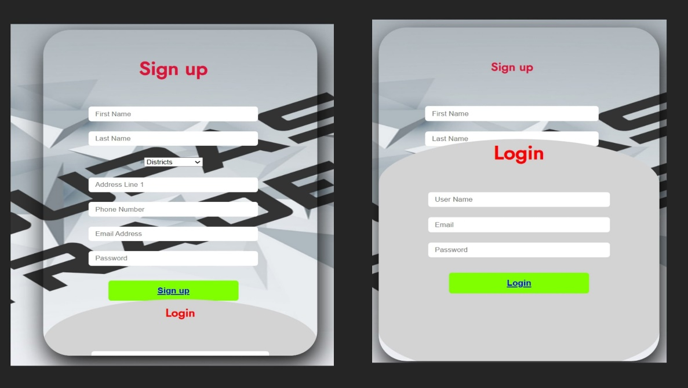

**3.Product Page**

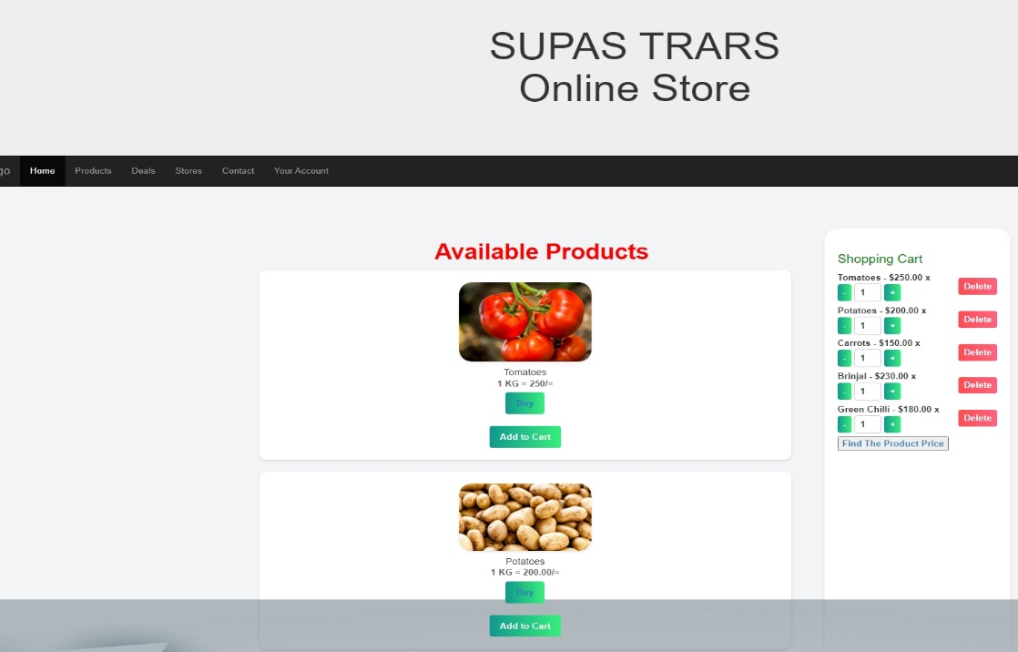

**4.Order page**

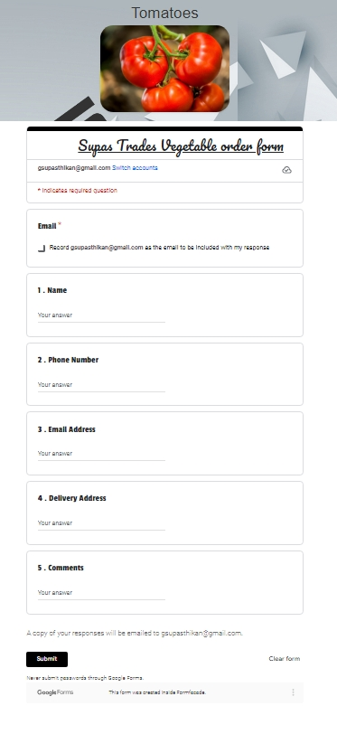

**5.Contact Page**



**REFERENCES**

* 1. W3SCHOOLS
  2. YOUTUBES
  3. CHATGPT

THANK YOU